**Informatica Project**

**Project 3:**

Design the ETL  mapping, to read the employee data from DB (HR database)  to join with the Department table and create employee wise target information for each department wise  dynamically.  
  
Output file below:  
emp_IT.txt  
emp_SA.txt  
emp_Admin.txt  
emp_hr.txt

Solution:

**Source:**

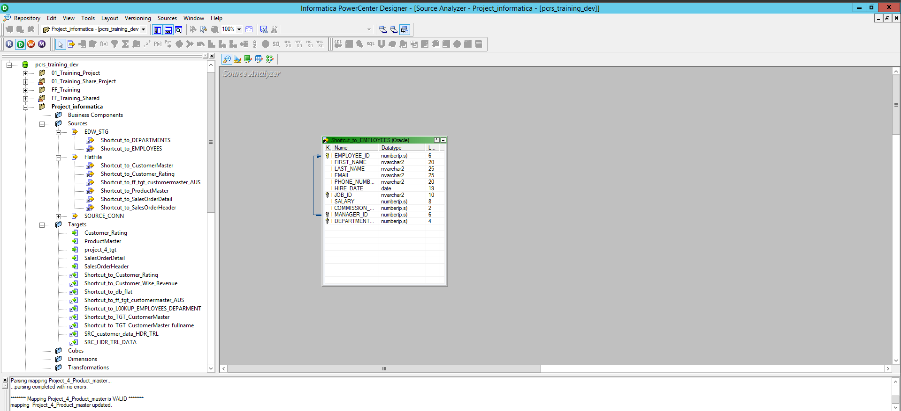

**Target:**

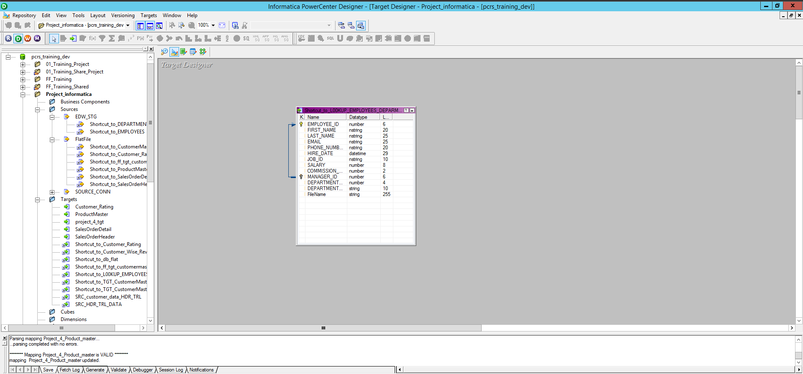

**Mapping:**

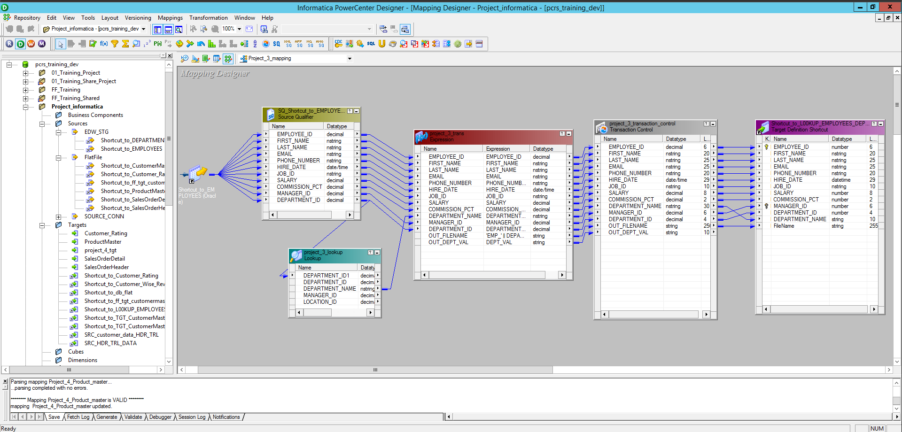

**Workflow:**

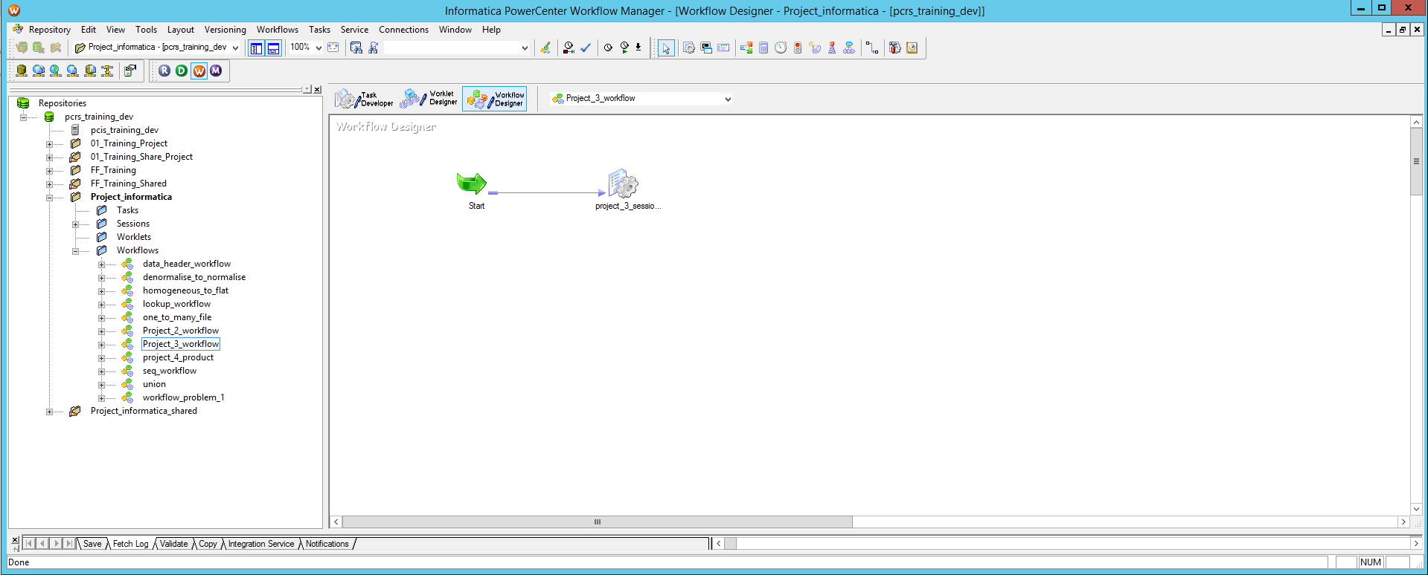

**Monitor:**



**Output:**

